**Architecture Document for EduExcellence School Management Software**

**1. Introduction**

**1.1 Purpose**

The purpose of this document is to outline the architecture of the School Management Software (SMS) for EduExcellence. The system is designed to manage all aspects of running a school, including student enrollment, attendance, grades, scheduling, teacher management, fee management, and more. The system is expected to evolve and scale as the school grows.

**1.2 Scope**

This document covers the overall architecture of the School Management Software, including the system’s components, data flow, security considerations, scalability, and technology stack.

**2. System Overview**

**2.1 High-Level Requirements**

* **Student Management:** Enrollment, attendance, academic records.
* **Teacher Management:** Profiles, schedules, performance tracking.
* **Course Management:** Curriculum setup, scheduling, resources.
* **Fee Management:** Billing, payments, financial records.
* **Communication:** Notifications, messaging between teachers, students, and parents.
* **Library Management:** Book inventory, lending records.
* **Transport Management:** Bus routes, student transport tracking.
* **Growth Capability:** Modular design for future enhancements.

**2.2 Non-Functional Requirements**

* **Scalability:** System should support increasing number of users and data volume.
* **Security:** Ensure data privacy and secure access.
* **Performance:** System should perform well under load with a target of <2s response time for all operations.
* **Availability:** The system should have an uptime of 99.9%.
* **Maintainability:** Codebase should be modular and easy to maintain.

**3. Architecture Design**

**3.1 Architectural Style**

* **Microservices Architecture:** The application will be composed of loosely coupled, independently deployable services. Each service will be responsible for a specific business capability (e.g., Student Management, Fee Management, etc.).

**3.2 High-Level Architecture Diagram**

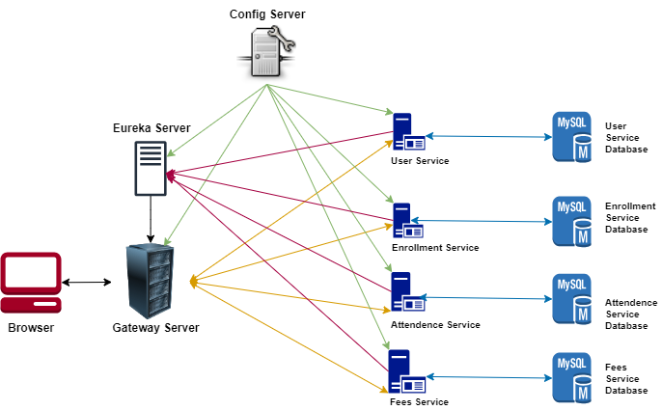

**3.3 Service Breakdown**

* **User Service:** Manages student, teacher, and administrative user profiles.
* **Enrollment Service:** Handles student admissions and registrations.
* **Attendance Service:** Tracks daily attendance for students and staff.
* **Fee Service:** Processes billing, payments, and financial tracking.

**3.4 Data Flow**

* **API Gateway:** All external requests go through the API Gateway, which routes them to the appropriate microservice.
* **Internal Communication:** Services will communicate with each other using RESTful APIs or gRPC.
* **Data Persistence:** Each service will have its own dedicated database, supporting data isolation and scalability.

**3.5 Technology Stack**

* **Frontend:** React.js or Angular for a responsive and interactive user interface.
* **Backend:**
  + **Programming Language:** Spring Boot.
  + **API Gateway:** API Gateway Server
  + **Database:** MySQL.
  + **Message Broker:** Apache Kafka for asynchronous communication.
  + **Authentication:** OAuth 2.0/JWT for secure user authentication.
  + **Containerization:** Docker for containerization of services.
  + **Orchestration:** Kubernetes for managing containerized applications.
  + **CI/CD Pipeline:** Jenkins/GitLab CI for continuous integration and deployment.

**4. Security Considerations**

**4.1 Authentication and Authorization**

* Implement OAuth 2.0 for user authentication.
* Role-based access control (RBAC) to manage permissions.

**4.2 Data Encryption**

* Encrypt sensitive data at rest and in transit using AES-256 and TLS respectively.

**4.3 API Security**

* Implement rate limiting, input validation, and logging for all API endpoints.

**5. Scalability and Performance**

**5.1 Horizontal Scaling**

* Use Kubernetes for scaling microservices independently based on demand.

**5.2 Caching**

* Implement Redis or Memcached to cache frequently accessed data to improve performance.

**5.3 Load Balancing**

* Use a load balancer (e.g., AWS ELB) to distribute incoming requests evenly across services.

**6. Monitoring and Logging**

**6.1 Monitoring**

* Use Prometheus/Grafana for real-time monitoring of system health and performance.

**6.2 Logging**

* Centralize logging using ELK Stack (Elasticsearch, Logstash, Kibana) or a similar solution.

**7. Deployment Strategy**

**7.1 Continuous Integration/Continuous Deployment (CI/CD)**

* Automate testing, build, and deployment processes using Jenkins or GitLab CI.
* Deploy in a rolling fashion to minimize downtime.

**7.2 Environments**

* Maintain separate environments for development, testing, staging, and production.

**8. Future Enhancements**

* **AI/ML Integration:** For personalized learning and analytics.
* **Mobile Application:** Extend functionality to mobile platforms.
* **Third-Party Integrations:** Integrate with third-party educational tools and platforms.

**9. Conclusion**

This document provides a comprehensive overview of the architecture for the EduExcellence School Management Software. The design is modular, scalable, and secure, ensuring that the software can grow alongside the school.